Design things: Nov 16

Some fixes still needed to be implemented

* Login button should extend to the arrow icon as well as the bar that contains "Login"
* Dashboard's texts need to be vertically aligned
* Various request views' texts' background is opaque

(They are currently opaque, but should not be opaque)

Changes to functionality (not yet implemented)

* As the design spec do not include acceptance of offline invitation request, when any user logs in, the dashboard will have "Start Conference." Upon an invitation request to a conference room, when the person accepts, the dashboard changes to "Go to Conference"

-menu button does not pop up on dashboard

-menu button brought up overlay that is too tall

-menu can't be rid of by pressing again with menu visible

-If possible, disable automatic orientation changes.

-Bug: If it rotates twice, the new conference button disappears.

-There are color inaccuracies (Background of main conference too dark)

-Textbox: square, not rounded corners.

-Textbox default text not needed

Re-size the  to 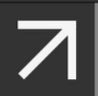

and  to  (They are too large)

-dashboard sexybar has no border

-sexybar border not fully extended horizontally

Background color: 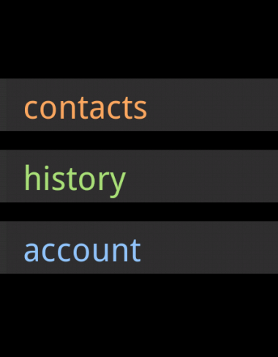 to 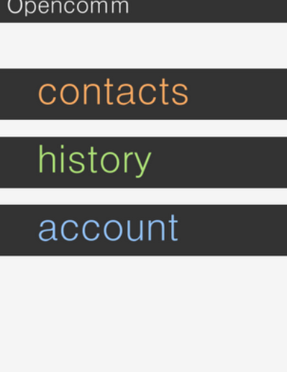

(From this black color to the light white color) (Not too sure on this, black looks nicer, but we did spec white..)

Start conference button - overlay is black, instead of a 40% opacity white overlay.

Menu key - the menu overlay should be 90% black opacity. Also, pressing a button on the menu key decreased the opacity instead of putting a 40% opacity white overlay on top.

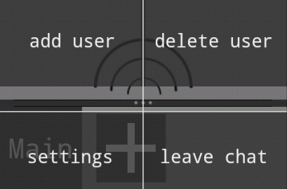

This is prior to clicking the "settings" and "leave chat" key. (Bottom 2 key more opaque.

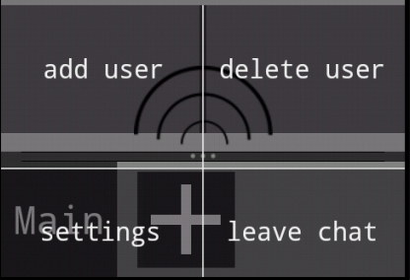 to

This is after clicking the "settings" and "leave chat" key. (Bottom 2 key less opaque)

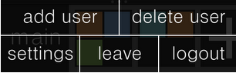

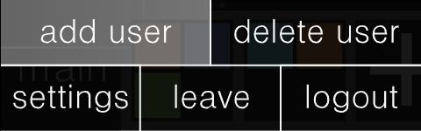

This is the 40% white opacity overlay that is applied during click.

-(not too important) hold to click should pop up after a couple seconds, not when finger is released.

This is prior to clicking the "settings" and "leave chat" key

This is prior to clicking the "settings" and "leave chat" key